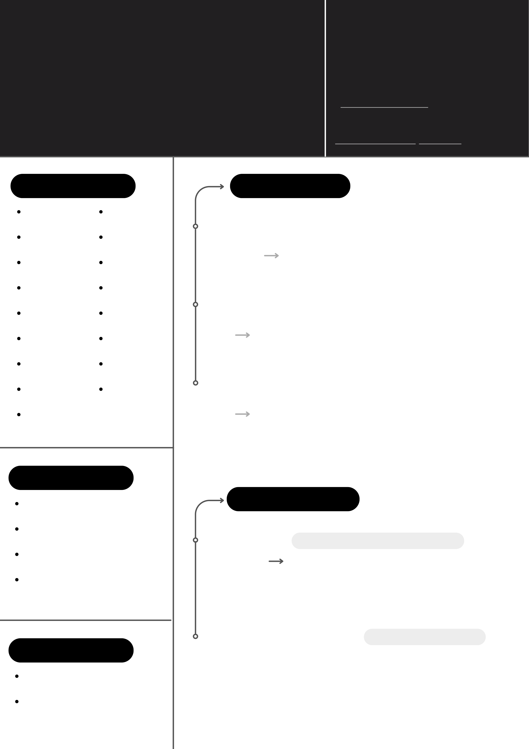

|  |  |  |
| --- | --- | --- |
| **Justine Leleu** | License | Address |
| B + personal vehicle | Mons |
| **Java Developer** | www.linkedin.com/in/justineleleu/ | github.com/JustineLeleu |
| justine.leleu@hotmail.com | +32 491 07 75 77 |

As a passionate developer for programming and video games, I started as a gameplay programmer. I then started to explore web development. Finally discovering an interest in applications development in Java and the challenges it brings with it.

Github   
[github.com/JustineLeleu](https://github.com/JustineLeleu)

LinkedIn   
[www.linkedin.com/in/justineleleu/](https://www.linkedin.com/in/justineleleu/)

|  |  |  |  |  |
| --- | --- | --- | --- | --- |
| **Compétences** | Maven | **Helha, Mons Education** | | |
| Java |
| 2020 | | |
| Spring | Spring Boot |
| Becode.org, Charleroi | | |
| C++ | UE4/UE5 | August 2023 | | March 2024 |
| 7 months formation of autonomous work discovering web | | |
| C# | Becode.org, Charleroi | development, front-end, back-end and Java. | | |
| Javascript | August 2023 | 2021 | | |
| Helha, Mons | | |
| CSS/SCSS | March 2024 | 2020 | 2021 | |

Helha, Mons

|  |  |  |  |
| --- | --- | --- | --- |
| Bootstrap | 7 months formation of autonomous work discovering web development, front-end, back-end and Java. | One year formation of discovering game development with Unreal Engine. | |
| SQL | Git/Github |
| Helha, Mons | |
| Perforce | 2017 | 2020 |

2017

**Soft skills**

|  |  |  |  |  |
| --- | --- | --- | --- | --- |
| Autonomous  Team work  Adaptation capacity Organized  **Languages**  As a passionate developer for programming and video games, I started as a gameplay programmer. I then started to explore web development. Finally discovering an interest in applications development in Java and the challenges it brings with it. | **Experiences** | | | |
| Wushu Legacy | | *justine.leleu@hotmail.com* | |
| January 2021 | May 2021 | | Helha, Mons |
| +32 491 07 75 77 | | | |
| B + personal vehicle | | | *Gameplay (Global Game Jam)* |
| 2021 | | | Helha, Mons |
| Mons | | | |

English- Intermediate